Room A
AQ1 Appendiceal Carcinoid.
Stem:: A previously healthy 68-year-old woman is seen in the ED with 18 hours of RLQ abdominal pain and CT findings showing acute appendicitis without perforation, abscess, or phlegmon. The patient has no contraindications to surgery.
What is your differential diagnosis?
- Acute appendicitis
- Tumor
What would you like to do now?
Laparoscopic or Open Appendectomy (Describe )
Path Returns with 6mm well circumscribed carcinoid tumor near tip of appendix with no lymphovascular invasion or evidence of perforation ? Nothing further
Path Returns with 14mm well carcinoid tumor at mid appendix with lymphovascular invasion
- PET-Dotatate or Octreotide scan post op, with tumor markers
- Right Colectomy (Describe)
Path Returns with 34mm well-circumscribed carcinoid tumor at mid appendix without evidence of perforation or lymphovascular invasion.
1. Right colectomy
Scenario: At the time of surgery, a 3cm tumor is identified in the mid appendix without evidence of perforation
1. Right colectomy
Scenario: At the time of surgery an approximately 18mm tumor is palpated during an appendectomy near the tip of the appendix after opening the appendix on the back table because of the firm palpable mass. Frozen specimen returns with likely carcinoid tumor.
1. No further surgery required.
Pathology returns with adenocarcinoma:
1. Right colectomy
Scenario: There is a mucinous mass involving the base of the appendix. During mobilization and right colectomy there is spillage of mucin. What next?
- referral for evaluation for HIPEC. Decision to HIPEC will be based on serial imaging, pathology (benign vs. adenocarcinoma).
- if during appendectomy for mucinous mass there is evidence of mucin spillage consider peritoneal lavage/cytology

- Pitfalls:
- Ability to describe right colectomy.
- Appropriate surgical procedure
- Understands reason for referral to HIPEC.

AQ2 Pulsatile Abdominal Mass
Stem: A 76-year-old man referred to you after a routine physical examination by his primary physician. He abdominal pain, back pain, or claudication. He is having normal bowel movements, denies melena. The patient is retired, but active, and able to work in his yard and climb a flight of stairs without shortness of breath.
Physical exam: Vital signs are normal.
On abdominal examination, a pulsatile mass is noted in the epigastric region.
He has a well-healed right lower quadrant scar.
He has palpable femoral, popliteal, dorsalis pedis, and posterior tibial pulses bilaterally.
PMH: hypertension, hyperlipidemia, and a 40-pack-year history of smoking
PSH: Open appendectomy 56 years ago
What is your differential diagnosis?
- Aneurysm, Abdominal aortic most likely.
- Pulsatile abdominal tumor.
- Pancreatic pseudocyst
- Hepatomegaly.
How are you going to evaluate this patient?
- CT Abdomen and pelvis with IV contrast. (5.8-cm abdominal aortic aneurysm (AAA) that begins 2 cm below the renal arteries, The iliac arteries are not aneurysmal, with a diameter of 1 cm bilaterally.)
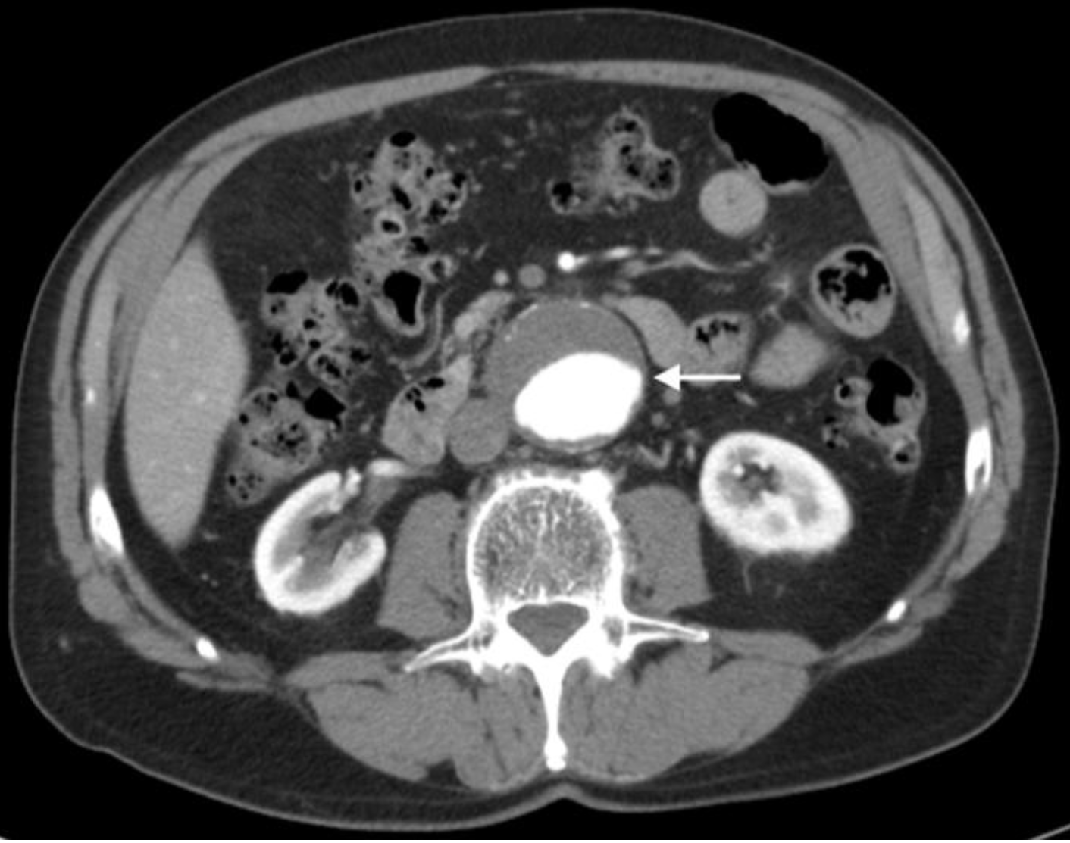
- Duplex of lower extremities.
- CBC (Hb of 14 g/dl) BMP (Creatinine 0.9 mg/dl)
What would you offer this patient? – Repair (> 5.5 cm)
Any specific imaging in preparing for repair? CT with 3 D Reconstruction
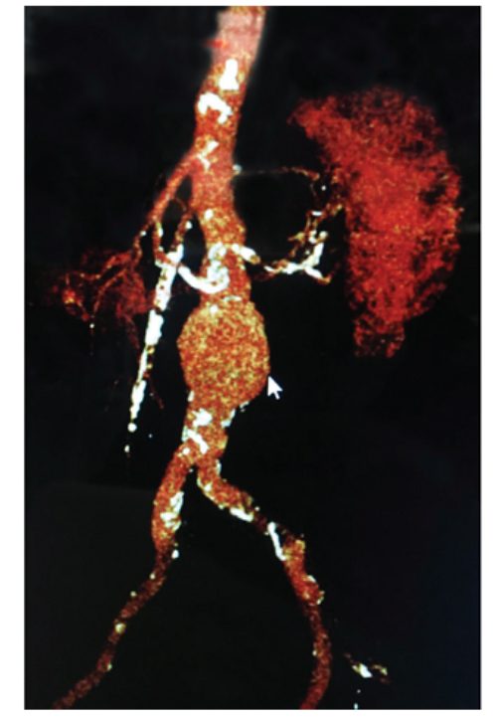
How would you approach it ?
- EVAR : Preferred Method
What criteria makes a patient candidate for EVAR?
- Aneurysm neck must be at least 10 to 15 mm in length and have a diameter of <32 mm.
- The proximal neck should also have an angulation of <60° in order to decrease the risk of device migration and endoleak.
- Additionally, the iliac arteries must be of appropriate diameter (6 to 8 mm) and without significant tortuosity to allow for delivery of the endograft device.
Describe EVAR?
- Choose appropriate endograft based on 3D reconstruction of CT scan.
- Expose the common femoral arteries bilaterally or place closure devices.
- Insert sheaths and catheters; perform abdominal and pelvic aortogram.
- Administer heparin.
- Insert main body of endograft just below renal arteries.
- Obtain wire access of contralateral side gate of endograft.
- Place contralateral iliac limb.
- Balloon angioplasty sealing zones and joints.
- Perform completion angiogram and assess for presence of endoleaks
- Administer protamine to reverse heparin.
- Close arteriotomies and groin wounds or deploy closure devices, check distal pulses.
On complaetion angiogram, endoleak type 1 noted, How would you manage?
Type I leak at either the proximal or distal landing zones of the endograft is treated with either balloon angioplasty or graft extension.
What if it was type III endoleak?
A type III leak at the junction of graft components is typically addressed with placement of a new stent–graft component across the defect with subsequent balloon angioplasty.
How do you classify endoleaks?
- Type Ia—Failure of seal at proximal aortic neck.
- Type Ib—Failure of seal at one of the distal iliac landing sites.
- Type II—Continued flow into aneurysm sac via a branch artery, typically a lumbar artery or the inferior mesenteric artery.
- Type III—Leak at junction of the main body of the graft and iliac limb.
- Type IV—Pressure in the aneurysm sac due to leak from small holes in graft material.
- Type V—Seroma or hygroma.
How would you follow this patient?
Patients need surveillance CT scans at 1 and 12 months following EVAR, then annually thereafter to check for endoleaks.
Open AAA repair (If time allows):
- Midline abdominal incision.
- Reflect small bowel to right, transverse colon superiorly, insert self-retaining retractor.
- Dissect duodenum off of the aorta, and define proximal clamp site.
- Dissect distal aorta and proximal iliac arteries, taking care to avoid sympathetic nerves.
- Choose appropriate graft size, administer heparin, furosemide, and mannitol.
- Clamp iliac arteries followed by proximal aorta.
- Open aneurysm sac opposite IMA, remove thrombus, and oversew back bleeding lumbar arteries.
- Sew in graft starting proximally, then distally, with monofilament suture. Reestablish blood flow through graft, administer protamine, obtain hemostasis.
- Close aneurysm sac and retroperitoneum over graft.
- Close abdomen, check distal pulses.
Pitfalls:
- Not recognizing that AAA should be repaired when the diameter is larger than 5.5 cm
- Not recognizing Endovascular repair has become the standard of care in patient who have suitable arterial anatomy.

References:
Chaikof EL, Brewster DC, Dalman RL, et al. The care of patients with an abdominal aortic aneurysm: the Society for Vascular Surgery practice guidelines. J Vasc Surg. 2009;50(4 suppl):S2-S49.
Dangas G, O’Connor D, Firwana B, et al. Open versus endovascular stent graft repair of abdominal aortic aneurysms: a meta-analysis of randomized trials. JACC Cardiovasc Interv. 2012;5(10):1071-1080.
Eliason JL, Upchurch GR Jr. Endovascular abdominal aortic aneurysm repair. Circulation. 2008;117(13):1738-1744.
Erbel R, Aboyans V, Boileau C, et al. 2014 ESC guidelines on the diagnosis and treatment of aortic diseases: document covering acute and chronic aortic diseases of the thoracic and abdominal aorta of the adult. The Task Force for the Diagnosis and Treatment of Aortic Diseases of the European Society of Cardiology (ESC). Eur Heart J. 2014;35(41):2873-2926.
EVAR Trial Participants. Endovascular aneurysm repair versus open repair in patients with abdominal aortic aneurysm (EVAR trial 1): randomised controlled trial. Lancet. 2005;365(9478):2179-2186.
Lederle FA, Freischlag JA, Kyriakides TC, et al. Outcomes following endovascular vs open repair of abdominal aortic aneurysm: a randomized trial. JAMA. 2009;302(14):1535-1542.
Lederle FA, Freischlag JA, Kyriakides TC, et al. Long-term comparison of endovascular and open repair of abdominal aortic aneurysm. N Engl J Med. 2012;367(21):1988-1997.

AQ3 Melanoma

Stem: A 40-year-old male presents with a pigmented lesion on his right lower extremity. First noticed it three months ago, denies recent changes in the appearance of the lesion. He uses sunscreen sporadically and recalls having sunburns as a teenager.
His medical and surgical history are unremarkable.
He denies a personal or family history of skin cancers.
Physical exam reveals this

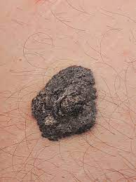

What is your differential diagnosis?
- Melanoma
- Melanocytic nevus
- Basal cell carcinoma
- Seborrhoeic keratosis
- Dermatofibroma

What would you like to do now?
- Complete skin exam evaluating for additional suspicious lesions, regional lymph node exam.
- Biopsy

Biopsy returns as melanoma, Breslow depth 1.2mm with no evidence of ulceration, mitotic rate < 1 mitosis/mm² (T2a)

What is Next?
Wide local excision and SLNB w/ margins of 1.0 to 2.0mm
Order immunohistochemistry for nodes (BRAF, S100)

Pathology returns as residual melanoma, Breslow depth 1.2mm, negative margins, 2 of 3 nodes positive for metastatic disease.
- Stage w/ PET CT
- Completion lymph node dissection VS active nodal surveillance w/ ultrasound.

What’s the risks and benefits of both?
- Lymphedema in CLND (24%) vs surveillance (6%)

Patient elects CLND, What’s now?
Inguinal lymph node dissection:
- Mark incision
- Dissect the subcutaneous until you reach superficial fascia (Campers fascia).
- Incise the fascia gently.
- Lift the fascia and dissect parallel to the lower border of the fascia to separate the superficial inguinal nodes from the subcutaneous tissue.
- Continue until you reach the inguinal ligament (upper border of the dissection).
- Dissect the superficial inguinal lymph nodes off the inguinal ligament starting from the upper edge of the ligament down to the femoral triangle.
- Dissect the lymph-nodes off the muscles.
- Separating the groin nodes off the femoral triangle floor proceeding from lateral to medial.
- Identify the great saphenous vein and dissect carefully until the point of insertion with the femoral vein.

- Adjuvant therapy options: nivolumab (programmed death 1 inhibitor)
- Or targeted therapy with combination of BRAF/MEK inhibitors;
(IFN alfa and ipilimumab have fallen out of favor)

- Follow up every 3-6 months for 2-3 years, then annually.

Patient selects active nodal surveillance, what is the recommended follow up?
- US affected nodal basin every 4 months for 2-3 years
- Annual PET CT
- Then every 6 months for next 2-3 years
- After 5 years, perform US annually until 10 years out from SLNB

Scenario: Another patient, referred by dermatologist for punch biopsy with Breslow depth of 0.7mm, no ulceration

1. Wide local excision with 1.0mm margins, no SLNB

Scenario 4: Same patient but has a firm, palpable lymph node in the right groin?! Now what?!

FNA : Metastatic melanoma (should not recommend excisional biopsy as it may interfere with future node dissection. How would you manage?!

- Test tumor for BRAF gene mutation
- Stage w/ CT c/a/p or PET CT +/- MRI brain:
(Regional disease appears borderline respectable.)
- Refer to medical oncologist for systemic therapy
Can you give examples?! Nivolumab (anti-PD-1 antibody), targeted therapy against BRAF (dabrafenib) or downstream target MEK (trametinib)
Patient shows good response.
Proceed with CLND

What is high risk recurrence and what would you recommend?
  - multiple nodes
  - Extracapsular extension

Consider adjuvant XRT to regional basin.

Pitfalls:
- Differential diagnosis must include Melanoma, Melanocytic nevus, Basal cell carcinoma.
- Knowledge of staging.
- Know when to do CLND.
- Know to consult medical oncology and treatment.

